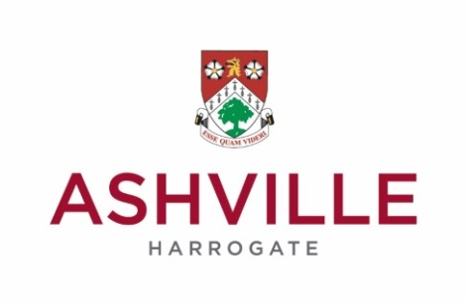
News release

06/11/2017

ASHVILLE BOASTS THREE CHAMPIONS AT YORKSHIRE BIATHLON TOURNAMENT
FOR IMMEDIATE RELEASE)

Ashville’s Biathlon Team have returned victorious from a major regional competition with three of its squad being crowned champions in their age group.

And, a total of 17 who took part in the Yorkshire Biathlon Championships held at York University, will now travel to this month’s National Championships in Solihull – a record number for Ashville.

Nico Jones came first in the U10s with a points total of 2372. In the U11s, Jacob Brown came first with 2528 points, and, in the U13s, Lucas Waligora finished first with 2271 points. All three recorded the fastest swim times in their age groups.

Additionally, in the U10s girls competition, Eleanor Grattoni-May finished eighth, whilst Oliver Bailey finished fourth, Patrick Rowley seventh and Harry Wright eighth in the boys heat.

The results for the U11s girls saw Annie Scott finish in eighth place, Carys Waligora, who recorded the fastest swim time, finish in tenth place. In thirteenth position was Jemima Herald.

William Cullen, who was the second fastest swimmer, finished sixth in the U11s boys.
The U12s girls race saw Agnes Pearson finish fifth, Audrey Otto sixth, Sadie Pringle tenth and Rosie Jones fourteenth. Meanwhile Agnes, Audrey and Sadie were second in the team event.

In the boys U12s Oliver Riley came third, Oliver Grattoni-May fifth, Ben Douglas – who recorded the second fastest swim time – sixth, and Edward Crack seventh.

The boys U13s saw Jake Normanshire, who recorded the second fastest run and swim times, finished second; Johnny Scott, who recorded the third fastest run and swim times, finished third. Daniel Winterhalder was fifth, Finn Wright sixth, James Chester eighth and Gage Folkerth ninth.

Lucas Waligora, Jake and Johnny won the team event whilst Daniel, Finn and James were second.

In the U13 girls Isabelle Barley was placed tenth, Olivia Parris eleventh and Nicola Crack twelfth. The trio also won the team event.

Charles Cullen came fourth in the U14s; in the U15s Charlotte Parris, who recorded the fastest run time, was fourth and Finlay Waligora, who recorded the fastest swim time, was second.

In the U16s Emma Moore, who recorded the fastest swim time, was second and in the U17s, Joe Moore came second. He also recorded the fastest swim time.

The 17 Ashville biathletes who have qualified for the national finals are Nico Jones, Oliver Bailey, Patrick Rowley, Jacob Brown - who is ranked fourth nationally going into these finals - Oliver Grattoni-May, Ben Douglas, Oliver Riley, Lucas Waligora, Olivia Parris, Isabelle Barley, Nicola Crack, Johnny Scott, Jake Normanshire, Charlotte Parris, Finlay Waligora, Emma Moore – ranked 20th nationally going into these finals – and Joseph Moore - ranked 14th nationally going into these finals

Duncan Archer, Head of Sports Development at Ashville, said: “This was a superb day for our young biathletes and I’m very proud of the team for their performances on the day.

“There were some outstanding individual efforts and I’m delighted that three, Lucas Waligora, Jacob Brown and Nico Jones, were each crowned Yorkshire Champions in their age groups.

“The finals are only a few weeks away and the 17 who qualified, a record number for Ashville, are training hard for the event.

-ends-

Founded in 1877, Ashville College is a leading independent day and boarding school for boys and girls aged 3-18 years. It is located in the North Yorkshire spa town of Harrogate, and consists of Acorns Pre-Prep, Ashville Prep School, Ashville Senior School and Ashville Sixth Form. Ashville College is a member of HMC, IAPS and part of the Methodist Independent Schools Group.

For further press information please call:
Marketing, Ashville College, on 01423 724 819
David Simister, Different PR, on 0845 389 2626

Picture Caption: Some of the Ashville biathletes who competed at the Yorkshire Biathlon Championships held at York University

