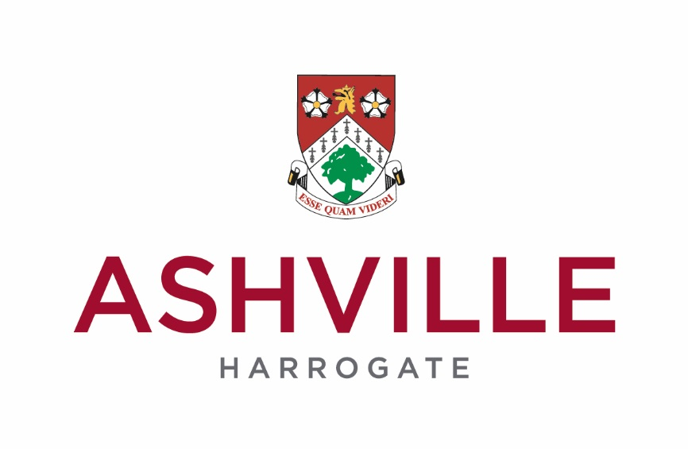
News Release
08/03/2017
Ashville College Pupil’s England Hockey Call Up
(for immediate release

An Ashville College sixth former’s hockey skills have been talent-spotted by the body which trains and selects future England players.

Will Farrar has been selected onto the Advanced Apprenticeship in Sporting Excellence (AASE) programme, which is led by the Performance Department at England Hockey.

The AASE programme, which commenced in January, will run for approximately 13 months. Will, 17, will attend four centralised national camps to receive coaching and performance support including nutrition, psychology and lifestyle advice underpinned by the AASE qualifications.

In addition, he and other young players, will benefit from a number of high quality technical and tactical coaching sessions held in the evening and at weekends.

The programme allows athletes to continue with their academic studies whilst gaining additional hockey performance experience and qualifications; certificate in achieving excellence in sports performance and certificate in understanding sports performance.
This qualification now carries 46 UCAS points; supplementing a player’s academic profile giving increased value and opportunity as athletes look to gain entrance to universities, obtain scholarships and jobs.

Phil Holmes, Ashville College’s Director of Sport, said: “We are absolutely delighted for Will in being selected to join the AASE programme.

“Will is a superb hockey player and this high-level coaching will benefit him hugely. He will be learning from the best as well as his peers, and we are hopeful it will lead to him winning a place on the England team.

“Over the last few years Ashville has benefitted from significant investment in its sports facilities, which has included a £750,000 all-weather surface pitch for our hockey teams to practice and play on.”

- Founded in 1877, Ashville College is a leading independent day and boarding school for boys and girls aged 4-18 years. It is located in the North Yorkshire spa town of Harrogate, and consists of three schools, Pre-Prep, Junior and Senior. Ashville College is a member of HMC, IAPS and part of the Methodist Independent Schools Group.
-ends-
For further press information please call:
Kate Linfoot, Ashville College, on 01423 724 819
David Simister, Different PR, on 0845 389 2626

Picture Caption: Hockey Star! Ashville College’s Will Farrar

